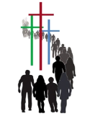
Pickering Pentecostal Church

Additional forms available at the Information Centre
January 2023

Dear PPC Supporter:

Thank you for your interest and participation in the pre-authorized debit (PAD) donation plan here at Pickering Pentecostal Church. We believe this is a great opportunity for you to faithfully support the ministry here and enable PPC to further God’s work in our community. Your consideration of PAD infers that you already believe in and support the ministry of PPC – thank you!

PAD enables you to contribute to PPC at least once a month without having to worry about the details. PAD also helps PPC leadership to plan more effectively, and also allows you to support PPC if, for some reason, you are away for a period of time (work; vacation, etc.)

Please be assured that the information required to set up the fund donations is confidential. The transactions are being processed through our financial institution, Bank of Montreal, and BMO’s secure web features.

The forms to facilitate PAD are similar to other PAD payments with original authorization forms and a “void” cheque. The attached forms (Payor’s PAD Agreement [both sides] & PAD Designation Form) are to be completed and, once returned, your offering will be processed for the date(s) of the month that you have selected. The donation will be debited from the specified account and a credit to “Pickering Pentecostal Church” will appear on your bank statement. One item to note about PPC’s plan is the flexibility of the debits from your account. If you would like to contribute the same amount more than once a month, please indicate your date choices. When completing the forms, please ensure the information is correct and that the “void” cheque is returned. Please note the designation form that will identify your allocation and which becomes a source document for year-end tax receipts. These designations will remain in effect until you advise us differently. We have included a sample PAD agreement form to assist you in filling out the agreement correctly.

Any applicable banking fees are associated with your personal bank arrangements; PPC will not request any fees/charges/services. If you would like to make amendments once your PAD is in effect, you will need to give at least 10 business days prior to the next PAD date by contacting info@ppclife.ca or rowens@ppclife.ca.

Again, thanks for your interest & participation – if you would like further information, please email me at the above address or contact me at 905-428-6888 ext. 104.

God Bless,
Rob Owens

SAMPLE PAYOR'S PAD AGREEMENT
Personal Pre-Authorized Debit Plan

PAYOR INFORMATION (Please type or print clearly)
Payor Name(s): John & Jane Doe
Address: 1234 Nice Drive, Pickering, ON, L1V 3E7
Telephone: 905-123-4567
Signature of Payor(s):  John Doe Jane Doe | Date: Mar. 10, 2023

PAYOR FINANCIAL INSTITUTION/BANKING INFORMATION (Please type or print clearly)
Branch Number |  |  |  |  | Institution # |  |  | Account Number
1 | 2 | 3 | 4 | 5 | 0 | 0 | 1 |  | 6 | 7 | 8 | 9 | 1 | 2 | 3
Name of Financial Institution: Bank of Canada
Branch: Kingston & Whites
Branch Address: 1912 Whites Road
City/Province: Pickering, ON |  |  |  |  |  |  |  |  |  |  |  |  |  |  |  | Postal Code: L1V 1C2

PAYEE INFORMATION
Payee Name(s): Pickering Pentecostal Church
Address: 1920 Bayly Street, Pickering, ON, L1W 3R6
Telephone: 905.428.6888; Fax: 905.428.8463; Email: info@ppclife.ca

PAYMENT INFORMATION (Please type or print clearly)
Please specify the total amount of the fixed payment: | $500
Please specify the date(s) for withdrawal. (Please circle at least one date or your choice) | 2nd, 10th, 18th, 25th of each month  Your choice(s) _____________________ of each month
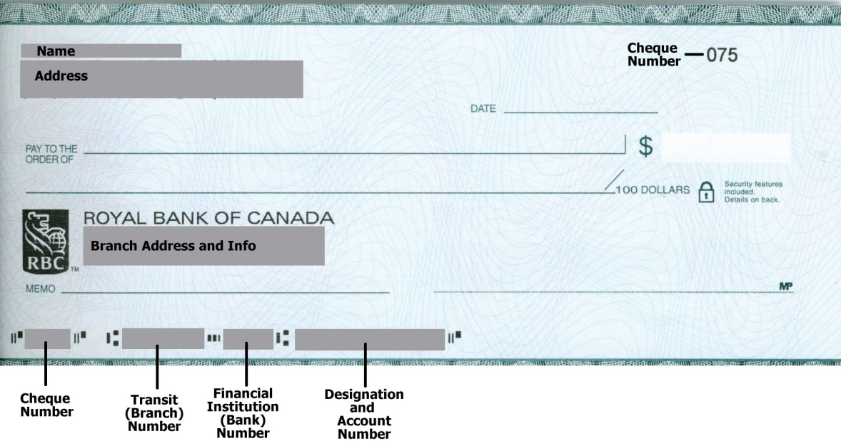
VOID

PAYOR'S PAD AGREEMENT
Personal Pre-Authorized Debit Plan
Terms & Conditions

1. In this Agreement , “I”, “me” and "my" refers to each Account Holder who signs below.
2. I agree to participate in this Pre-Authorized Debit Plan for personal/household or consumer purposes.
I authorize the Payee indicated on the reverse hereof and any successor or assign of the Payee to draw a debit in paper, electronic or other form for the purpose of making payment for charitable donations (a "Personal PAD") on my account indicated on the reverse hereof (the "Account") at the financial institution indicated on the reverse hereof (the "Financial Institution").
I authorize the Financial Institution to honour and pay such debits.
This Agreement and my authorization are provided for the benefit of the Payee and my Financial Institution and are provided in consideration of my Financial Institution agreeing to process debits against my Account in accordance with the Rules of the Canadian Payments Association.
I agree that any direction I may provide to draw a Personal PAD, and any Personal PAD drawn in accordance with this Agreement, shall be binding on me as if signed by me, and, in the case of paper debits, as if they were cheques signed by me.
3. I may revoke or cancel this Agreement at any time upon notice being provided by me either in writing or orally. I acknowledge that in order to revoke or cancel the authorization provided in this Agreement, I must provide notice of revocation or cancellation to the Payee.
This Agreement applies only to the method of payment and I agree that revocation or cancellation of this Agreement does not terminate or otherwise have any bearing on any contract that exists between me and the Payee.
The Payee shall use best efforts to cancel the PAD in the next business, billing or processing cycle but shall within not more than 30 days from the notice cease to issue any new PADs.
I understand that I may obtain a sample cancellation form, or further information on my right to cancel a PAD Agreement, at my financial institution or at www.cdnpay.ca.
4. I agree that my Financial Institution is not required to verify that any Personal PAD has been drawn in accordance with this Agreement, including the amount, frequency and fulfillment of any purpose of any Personal PAD.
5. I agree that delivery of this Agreement to the Payee constitutes delivery by me to my Financial Institution. I agree that the Payee may deliver this Agreement to the Payee's financial institution and agree to the disclosure of any personal information which may be contained in this Agreement to such financial institution.
6. I agree to abide by the pre-notification requirements as agreed to with the Payee.
7. I certify that all information provided with respect to the Account is accurate and I agree to inform the Payee, in writing, of any change in the Account information provided in this Agreement at least ten (10) business days prior to the next due date of a Personal PAD. In the event of any such change, this Agreement shall continue in respect of any new account to be used for Personal PADs.
8. I understand that I have certain recourse/reimbursement rights if any debit does not comply with this agreement. For example, I have the right to receive reimbursement for any debit that is not authorized or is not consistent with this PAD Agreement. I understand that I may obtain more information on my recourse/reimbursement rights by contacting my financial institution or visit the CPA website at www.cdnpay.ca.
9. I warrant and guarantee that all persons whose signatures are required to sign on the Account have signed this Agreement below. In addition I warrant and guarantee, where applicable, that I have the authority to electronically agree to commit to this Agreement by secure electronic signature and that my secure electronic signature conforms to the requirements of Rule H1.
10. I understand and agree to the foregoing terms and conditions.
11. I agree to comply with the Rules of the Canadian Payments Association or any other rules or regulations which may affect the services described herein, as may be introduced in the future or are currently in effect and I agree to execute any further documentation which may be prescribed from time to time by the Canadian Payments Association in respect of the services described herein.

John Doe John Doe Nov. 10, 2023
______________
Name of Account Holder Signature Date
Jane Doe Jane Doe Nov. 10, 2023
______________
Name of Account Holder Signature Date

PAYOR'S PAD AGREEMENT
Personal Pre-Authorized Debit Plan
Authorization of the Payor to the Payee to Direct Debit an Account

Instructions:
1. Please complete all sections in order to instruct your financial institution to make payments directly from your account.
2. Please sign the Terms and Conditions on the opposite side of this page.
3. Return the completed form with a blank cheque marked "VOID" to the Payee at the address noted below
4, Please include the completed fund designation form (otherwise we will assume all donations are to the general fund)
5. If you have any questions, please email, write or call the Church Office.

PAYOR INFORMATION (Please type or print clearly)
Payor Name(s):

Address:

Phone: Email:

Signature of Payor(s): | Date:

PAYOR FINANCIAL INSTITUTION/BANKING INFORMATION (Please type or print clearly)
Branch Number |  |  |  |  | Institution # |  |  | Account Number
Name of Financial Institution

Branch

Branch Address

City/Province |  |  |  |  |  |  |  |  |  |  |  |  |  |  |  | Postal Code

PAYEE INFORMATION
Payee Name(s): Pickering Pentecostal Church
Address: 1920 Bayly Street, Pickering, ON, L1W 3R6
Telephone: 905.428.6888; Fax: 905.428.8463; Email: info@ppclife.ca

PAYMENT INFORMATION (Please type or print clearly)
Please specify the total amount of the fixed payment: | $ _______________
Please specify the date(s) for withdrawal. (Please circle at least one date or specify your choice) | 1st, 2nd, 10th, 15th, 18th, 25th of each month;  Your Choice(s):___________________of each month;

PAYOR'S PAD AGREEMENT
Personal Pre-Authorized Debit Plan
Terms & Conditions

1. In this Agreement , “I”, “me” and "my" refers to each Account Holder who signs below.
2. I agree to participate in this Pre-Authorized Debit Plan for personal/household or consumer purposes.
I authorize the Payee indicated on the reverse hereof and any successor or assign of the Payee to draw a debit in paper, electronic or other form for the purpose of making payment for charitable donations (a "Personal PAD") on my account indicated on the reverse hereof (the "Account") at the financial institution indicated on the reverse hereof (the "Financial Institution").
I authorize the Financial Institution to honour and pay such debits.
This Agreement and my authorization are provided for the benefit of the Payee and my Financial Institution and are provided in consideration of my Financial Institution agreeing to process debits against my Account in accordance with the Rules of the Canadian Payments Association.
I agree that any direction I may provide to draw a Personal PAD, and any Personal PAD drawn in accordance with this Agreement, shall be binding on me as if signed by me, and, in the case of paper debits, as if they were cheques signed by me.
3. I may revoke or cancel this Agreement at any time upon notice being provided by me either in writing or orally. I acknowledge that in order to revoke or cancel the authorization provided in this Agreement, I must provide notice of revocation or cancellation to the Payee.
This Agreement applies only to the method of payment and I agree that revocation or cancellation of this Agreement does not terminate or otherwise have any bearing on any contract that exists between me and the Payee.
The Payee shall use best efforts to cancel the PAD in the next business, billing or processing cycle but shall within not more than 30 days from the notice cease to issue any new PADs.
I understand that I may obtain a sample cancellation form, or further information on my right to cancel a PAD Agreement, at my financial institution or at www.cdnpay.ca.
4. I agree that my Financial Institution is not required to verify that any Personal PAD has been drawn in accordance with this Agreement, including the amount, frequency and fulfillment of any purpose of any Personal PAD.
5. I agree that delivery of this Agreement to the Payee constitutes delivery by me to my Financial Institution. I agree that the Payee may deliver this Agreement to the Payee's financial institution and agree to the disclosure of any personal information which may be contained in this Agreement to such financial institution.
6. I agree to abide by the pre-notification requirements as agreed to with the Payee.
7. I certify that all information provided with respect to the Account is accurate and I agree to inform the Payee, in writing, of any change in the Account information provided in this Agreement at least ten (10) business days prior to the next due date of a Personal PAD. In the event of any such change, this Agreement shall continue in respect of any new account to be used for Personal PADs.
8. I understand that I have certain recourse/reimbursement rights if any debit does not comply with this agreement. For example, I have the right to receive reimbursement for any debit that is not authorized or is not consistent with this PAD Agreement. I understand that I may obtain more information on my recourse/reimbursement rights by contacting my financial institution or visit the CPA website at www.cdnpay.ca.
9. I warrant and guarantee that all persons whose signatures are required to sign on the Account have signed this Agreement below. In addition I warrant and guarantee, where applicable, that I have the authority to electronically agree to commit to this Agreement by secure electronic signature and that my secure electronic signature conforms to the requirements of Rule H1.
10. I understand and agree to the foregoing terms and conditions.
11. I agree to comply with the Rules of the Canadian Payments Association or any other rules or regulations which may affect the services described herein, as may be introduced in the future or are currently in effect and I agree to execute any further documentation which may be prescribed from time to time by the Canadian Payments Association in respect of the services described herein.

______________
Name of Account Holder Signature Date

______________
Name of Account Holder Signature Date

Pickering Pentecostal Church | PAD Designation Form  (For new PAD donors and to make changes designation details)

I/We, __________________________________ (envelope # ________), have completed the “Payor’s PAD agreement,” authorizing Pickering Pentecostal Church to debit my account.

This contribution by me/us is to benefit:
Tithe / PPC General Fund | $
Missions Fund | $
Building Fund | $
PPC Other Fund: (indicate) | $
PPC Other Fund: (indicate) | $
Total Contribution: (should equal total on PAD agreement form) | $

Signed: _____________________________________ Date: ____________________, 20__

Name of Church PAD Contact: Rob Owens Phone Number: 905-428-6888x104

The use, retention, and disclosure of personal information collected from this form is done in compliance with privacy legislation, including, but not limited to, the Personal Information Protection and Electronic Documents Acts (2000, c.5).

